Freedom 21 Lifting Rudder Design
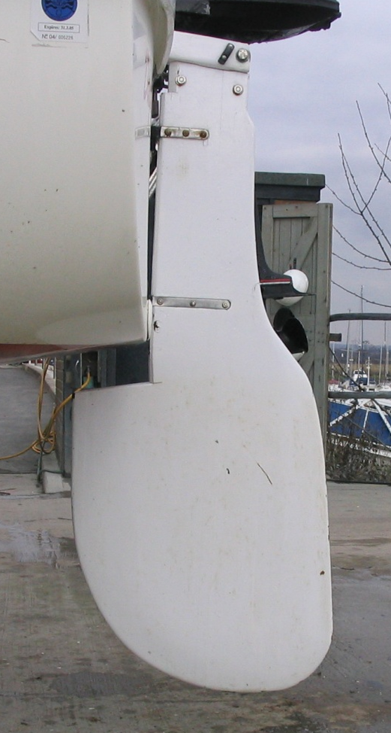
I sail a UK-built twin lift keel Freedom 21 which has a very shallow draught with the keels lifted (16”) and to take advantage of this these boats were fitted with a lifting rudder which consists of a simple galvanised steel plate pivoting in an aluminium alloy fabricated rudder stock. Unfortunately the previous owner of my boat had dispensed with his lifting rudder and had an improvised shallow draught fixed rudder installed that tends not to be able to develop sufficient “lift” to adequately control the boat when she is sailed in fresh to strong winds. The twin lift keel Freedom 21 has been out of production in the UK for about 18 years and I could not find a replacement lifting rudder so I decided to design and make a high performance lifting rudder for my boat. Since there had also been problems with the quality and strength of the rudder fittings on some of the UK-built Freedom 21’s I also decided to find and fit stronger and more appropriate replacement rudder gudgeon fittings to my boat.
The first step was to measure a number of Freedom 21 fixed rudders to determine the exact rudder planform and these dimensions are given in the attached Appendix 1. A check on the technical literature covering the design and effectiveness of sailing boat rudders showed that the standard Freedom 21 rudder seems to be an efficient, well balanced, modern design and details of these conclusions, together with the literature references are also given in Appendix 1.
I was unable to determine the specific aerofoil section used for the standard Freedom 21 fixed rudder but my literature search suggested that the best all-round rudder section would be the standard 4-digit NACA aerofoil section with a thickness/chord ratio in the range 9% to 12% and I decided to use a 9% thickness/chord section (NACA 0009). I also decided to adopt a “blunt” trailing edge for the rudder as this apparently can reduce drag and give a significant increase in lift and the exact dimensions for the rudder cross sections at the rudder tip, mid-span and root positions are given in Appendix 2.
I am fortunate to have available quantities of woven carbon fibre/epoxy resin composite laminate (CFRP) sheet available in various thicknesses and I decided to use these materials, together with the best quality BS1088 marine plywood for the fabrication of the rudder blade, finishing the rudder blade with epoxy resin saturation and a finishing layer of woven glass fibre epoxy.
The rudder blade make-up is shown in Figure 1 and is built-up around a “core” of 4.5mm (0.18”) CFRP laminate with two layers of 9mm (0.354”) marine plywood bonded on each side. The upper section of the rudder which pivots within the rudder cheeks has only 1 layer of 9mm marine plywood on each side of the 4.5mm (0.18”) “core” CFRP plate and has an additional layer of 2mm (0.08”) CFRP laminate bonded on each face to give a wear-resistant, durable surface to this region. All of these components were bonded together with an epoxy adhesive, taking care to keep all components in the correct location with waxed metal location pins fitted in pre-drilled location holes. This final precaution is well worth while as it totally eliminated any sliding and misalignment of the various rudder elements during the clamping and adhesive bonding operation.
After bonding these parts together I made-up a series of thin plywood templates to check the rudder sections at the rudder tip, mid-span and root positions and I carefully planed the rudder to its correct profile, checking regularly with the three templates – these templates are shown in Appendix 2 together with their precise dimensions. I had anticipated that this would be a difficult operation, but with really sharp plane blades and with the rudder blank securely attached to a well clamped baseboard I found this to be a straightforward job. Also the CFRP “core” laminate acted as a very effective “stop” when planing to ensure that a sharp-edged “blunt” cut-off trailing edge was achieved.
The rudder blade shaping process is described in detail in Appendix 2.
It was necessary to create a protruding trailing edge lug at the top of the rudder blade to allow a low-friction block to be fitted for lifting the rudder blade and this was achieved by routing away a small area of marine ply on each face of the rudder blade and epoxy bonding & pop-riveting two stainless steel plates to the CFRP “core” laminate as shown in Figure 2. A piece of phenolic resin/cotton fabric cured laminate (TUFNOL) was cut to size and epoxy bonded between the stainless steel plates to stabilise and complete the fitting. It was necessary to apply this fitting after the rudder blade had been planed to the correct profile and finished. The correct rudder blade profile was re-established by filling the cut-out area with polyester filler and carefully fairing this region back to the correct shape.
I made-up the rudder cheeks from CFRP laminate by bonding together a layer of 4.5mm (0.18”) and a layer of 2mm (0.08”) material to form the cheeks of the rudder head and I combined this with a teak inner packing layer. All three elements were bonded together with epoxy resin. The concept for lifting and lowering the rudder blade is as shown in Figure 3.

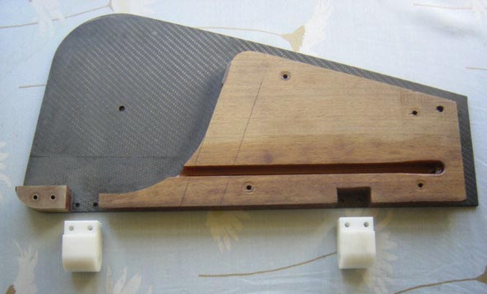
This photo shows the rudder head with the teak packer bonded to the CFRP cheek laminate. Again I used pre-drilled location holes to correctly align all parts and after all assembly bonding has been completed these holes were filled with epoxy resin prior to painting. The pre-cut slot for the rudder blade downhaul line is clearly seen. The CFRP cheek laminate that fits over this assembly carries a ball-race sheave box that takes the up-haul line out of the rudder head and down to a jamb cleat on the side of the rudder head. When sailing I do not rely on this down-haul line to hold the rudder blade down and I use a removable drop-head pin that passes through the rudder head and the rudder to “lock” the rudder down. When I come into shallow waters I remove this drop-head pin so that the rudder blade can then be raised as required.
The rudder gudgeon fittings are machined DELRIN components that I first noticed on the UK-built HAWK 20 Dayboat and needed only slight adjustment to fit my rudder head. On final assembly these DELRIN gudgeons are epoxy bonded into the rudder head and also through-bolted with stainless steel bolts.
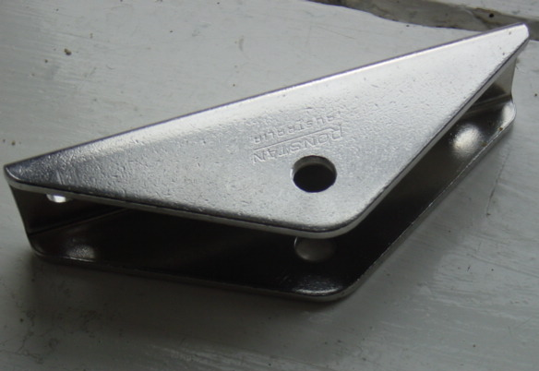
I had great difficulty finding strong enough gudgeon fittings for the transom since all the available fittings here in the UK seem fit only for sailing dinghies? However, I found these “as new” stainless steel RONSTAN gudgeons in a boat jumble which are ideal. Sadly these robust and well engineered fittings are no longer made by RONSTAN who have switched to an inferior anodised extruded aluminium alloy design? The finished rudder assembly is shown in the photographs on the next page together with a close-up of the anti-cavitation plate that I fitted to the top of the rudder blade that protrudes beneath the hull section immediately forward of the base of the transom.
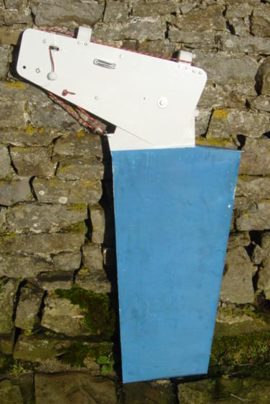
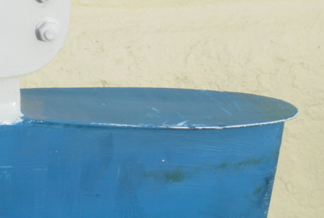
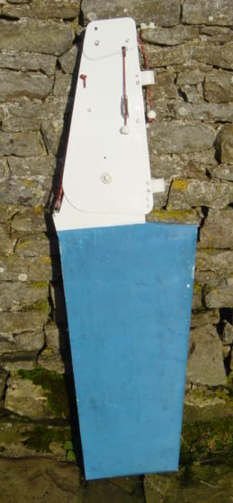
Lifting rudder showing rudder in the locked down & raised positions. The rudder is locked down by a stainless steel drop-head pin that passes through the rudder cheeks and the rudder blade.
Anti-cavitation plate fitted to the top of the rudder blade. This consists of a thin CFRP laminate bonded & screwed to the top of te rudder blade. When the lifting rudder is fitted to the boat this plate is about 25mm (1”) below the surface of the water.

Appendix 1
Summary of Rudder Design/Performance Information
Rudder T/E Cut-off Effect: One can “cut-off” up to around 10% of the rudder trailing edge chord with no appreciable effect on drag but with a significant increase in lift. For example, a 5% trailing edge chord cut-off on an NACA aerofoil produced a 10% increase in lift and a higher stall angle for the foil. (Ref 1 – p223)
Rudder Tip Shape (Cross Section): The best C_{L}/C_{D} ratio is given by a cross section tip shape consisting of “knife blade” edge, next best is a simple square cut tip & worst a rounded tip. (Ref 2 - p 52) Also the tip cross section has an influence on the tendency of the rudder to vibrate at high speed. A square cut tip has a relative vibration amplitude (RVA) of 1.0, a 45º included angle tip section rudder has an RVA of 0.43 and a 30º included angle tip section rudder has an RVA of zero. Poor tip shapes can have RVA values as high as 3.8. (Ref 3 - p128)
Rudder Blade Tip Profile (in Planform): A simple square cut tip profile works well as does a tip profile consisting of a shallow elliptical tip over the first 75% of the chord blending into a square tip. Other “clever” tip end shapes tend to increase drag. (Ref 2 - p51) The leading edge sweep angle should be minimised – preferably no more than 10º and the rudder blade taper ratio should be in range 0.4 to 0.6. (Ref 4 - p87)
Rudder Area: Should be in the range 8% to 10% of the total lateral plane area (TLP). If the rudder is a deep, high aspect ration design & transom hung the area could be reduced to around 7%. (Ref 4 - P87)
Rudder Balance: Balanced rudder blades minimise tiller loads and make steering easier – best balance found to be around 17%. (Ref 5 - p80)
Aspect Ratio: “Normal” aspect ratio for sailing boat rudders is 2.2 to 3.5. (Ref 5 – p77)
Aerofoil Shape: NACA 4-digit simple foil sections are best since the higher performance laminar flow sections are very critical of manufacturing accuracy and are not as “robust” in performance terms & toleration of non-optimum surface roughness & fouling. Also the leading edge profile and accuracy of the first 35% of laminar flow blade sections are very critical. The best compromise of highest lift angle, best lift coefficient and minimum drag is given by a foil with a thickness/chord ratio in the range 9% to 12%. The 4-digit NACA sections also give a more gradual stall characteristic. (Ref 4).
References
- Marchaj C A, Aero-Hydrodynamics of Sailing, Adlard Coles, London 1988, ISBN 0-229-11835-6.
- Gutelle P, The Design of Sailing Yachts, Macmillan, London 1984, ISBN 0-333-322681.
- Larsson L & Eliasson R E, Principles of Yacht Design, Adlard Coles, London 2000, ISBN 0-7163-5181-4.
- Vacanti D, Keel & Rudder Design, Professional Boatbuilder Magazine, June/July 2005
- Gerr D, Steering Systems Fundamentals - Part 1, Professional Boatbuilder Magazine, Dec/Jan 2006

Comparison of the Freedom 21 Rudder with Rudder Design Recommendations

Characteristic Recommendation Freedom Rudder
Rudder Area 8% to 10% of TLP 12.9% (Normal Fin Keel) 13.2% (UK Tandem Keel)
15.0% (UK Twin Lift Keel)
Rudder Balance 17% optimum 17%
Aspect Ratio 2.2 to 3.5 2.3
Taper Ratio 0.4 to 0.6 0.7
Leading Edge Sweep 10 degrees max. 10 degrees
Tip Cross Section Minimise RVA Square cut (RVA 1.0) – worst case RVA is 3.8
(RVA denotes “relative vibration amplitude”)
Aerofoil Section NACA 0009 or 0010 Production F21 rudder section not known
NOTES
- From the above table we can conclude that the Freedom 21 rudder is a relatively large, well tapered rudder, with optimum balance and an appropriate degree of leading edge sweepback.

- I decided to make my replacement lifting rudder to the standard F21 rudder planform with an NACA 0009 section with a 45º degree knife-edge “vee” cross section to the rudder tip and a 3% trailing edge “cut-off”. I also decided to fit a small anti-cavitation plate to the rudder to prevent entrainment of air at high speed which can evidently reduce rudder “lift” and cause rudder vibration to develop.

- I measured a number of F21 rudder blades and the attached sketch gives these dimensions.

- Comparing the predicted lift/drag characteristics of my new rudder with the lift/drag characteristics estimated for the improvised rudder originally installed I estimate that the new rudder gives me approximately 35% more “lift” than the existing rudder and has about 45% less drag than the existing rudder. Certainly the boat now “feels” more sensitive and needs far less rudder movement to control the boat.

Appendix 2
Dimensions of NACA 0009 Rudder Blade Sections
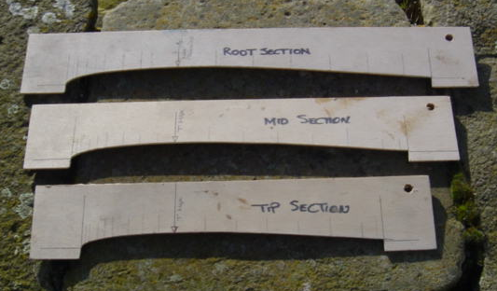
The NACA 0010 (10% thickness/chord ratio) aerofoil sections are taken from the published literature (Ref 4) and simply pro-rata modified to give the sections for a 9% thickness/chord ratio rudder blade. This information as required for the F21 lifting rudder blade is tabulated in Table 1. The simplest procedure is to make-up three aerofoil template sections in thin plywood for the rudder blade root, mid-span and tip positions as shown below. Note that I have market the % chord and maximum thickness positions on each template.
To start to shape the rudder blade blank plane the blank to a simple rectangular cross section so that it is finished to the correct thicknesses at the 30% chord position at all of the the three key reference points along the rudder blade – root, mid-span and tip. These three thicknesses are highlighted in orange in Table 1. Next start to plane the actual aerofoil section into the rudder blank using the three templates and checking frequently. Fortunately the layers within the plywood give a very good visual guide to the “trueness” of the planing and prevent one from planing hollows into the rudder blade. Also check frequenty along the span of the blade at the same % chord lines with a straight edge. The local radius at the leading edge of the aerofoil section is critical so take great care and shape this carefully with a really sharp small block plane. After thorough sanding I epoxy saturated the blade and applied a singly ply of 200 gsm (6 oz/sq.yd) plain weave glass fabric with epoxy resin.
Wilf Bishop
22nd January 2009

