Freedom 21 Mainsheet Snag on Traveller

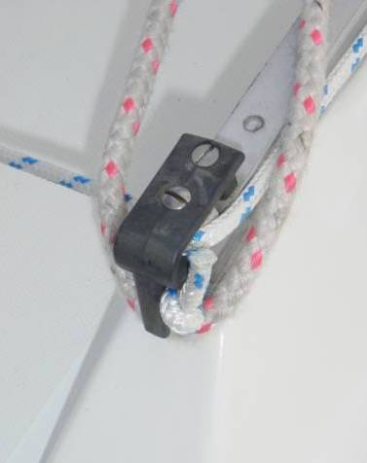
One minor but recurring problem with the cabin top mainsheet arrangement on the Freedom 21 is that when gybing, a loop of the mainsheet seems to frequently snag on the protruding end of the mainsheet traveller track that extends beyond the moulding on which it is mounted – see photo.

Whilst is normally not so difficult to reach over and flick the mainsheet free, the whole thing can be a little more exciting when sailing the boat single-handed in a stiff breeze.

The answer seems to be to create a fairing arrangement that prevents the mainsheet from jamming in the notch formed by the end of the traveller and the cabin top moulding.

I fitted a stainless steel strip appropriately bent into the correct “Z” shape and bolted one end though the cabin top moulding and the other end I screwed down to the traveller track using the screw that retains the traveller pulley.

This arrangement works very well and completely eliminates the mainsheet snagging problem.

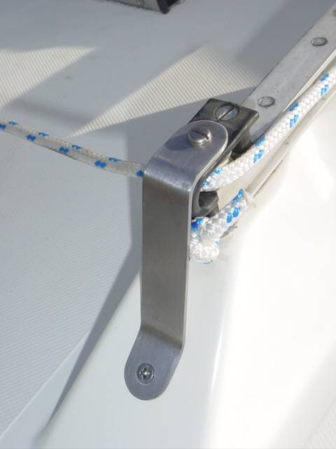
I used stainless steel strip 22mm wide and 2mm thick – a few hints about doing the job:

- Buy 3 strips of stainless steel so that you can use one piece to set-up the angles & bend radii positions. This first piece will almost certainly not fit correctly but can be used as a template to adjust the various parameters for the next two fittings.

- Bend the “Z” shape first before drilling any holes – you can accurately transfer hole positions for drilling later once the fitting is a really snug fit.

- I bent the strip by clamping it to a large diameter bolt in a mechanics vice to get generous bend radii. Take care to sight everything carefully before bending; otherwise you get a twisted fitting. I used a hide & copper mallet to bend the strips to avoid marking the stainless steel.

- Do not assume both sides will be exactly the same dimensions – make & fit each side separately.

Maybe this is just a problem on UK built boats and will not apply to USA built Freedom 21’s? Anyway this solves a minor problem on an otherwise excellent boat.

Wilf Bishop
26 May 2006

