**Freedom 21 Lifting Frame**

I own a UK-built Freedom 21 with the twin lifting keels and it has been a problem finding a means of lowering these keels when ashore for maintenance and antifouling. My yacht club only has a very shallow lifting gantry designed for lifting International Tempest keelboats on and off their road trailers and I decided to design a simple lifting frame to allow me to lift my Freedom 21 from her road trailer and suspend her in slings to carry out work on the twin lifting keels. The sketch below shows the concept for this lifting frame and the key dimensions.

F21 Lift Frame.tif

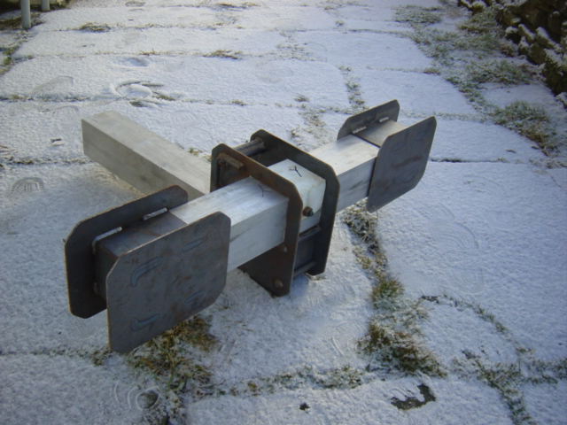The main elements of the frame consist of three lengths of 100mm x 100mm (4” x 4”) square-section hollow aluminium alloy tube with a wall thickness of 3.2mm (1/8”). I had mild steel plate box-section units welded-up to slide over the ends of the tube sections to make up the “H” shaped frame assembly. I used 6 metre (19ft 8”) circumference round-sling stitched webbing lifting loops to suspend the boat in the frame and adjusted the lengths of the two cross members to allow the boat to sit level when suspended from the frame. I used 6 metre lifting loops with a safe working load of 1 tonne (2200 lb) and a 7:1 safety factor which represents a good safety margin.

The steel plate end units for each of the two cross members are made with raised side plates to prevent the round-sling lifting loops from sliding off the cross members when the boat is lifted and these are clearly shown in the photo of the aft cross member fitted to a short length of tube section. Also shown in this photograph is the fibreglass “saddle” that fits over and is bolted through each cross member where it passes through the beam-end welded plate member. This “saddle” keeps the cross beam in place and prevents it from sliding through the beam-end member.

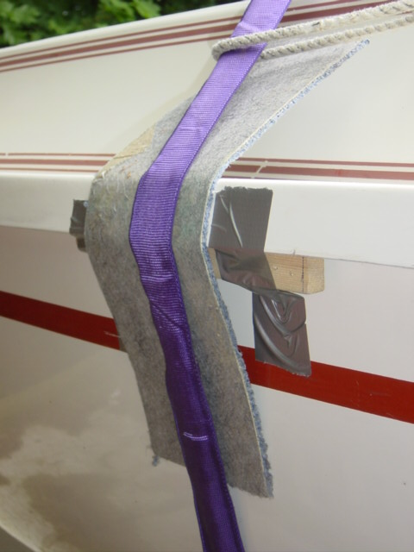I placed wooden chocks under the gunwales in the areas where the lifting loops would apply crushing loads to the hull, holding these chocks in place with duct tape. I also padded these areas with pieces of old carpet to prevent the lifting strops from scratching the hull. The “H” shaped frame was suspended from the chain hoist hook by two 2 metre (6ft 7”) webbing slings with a loop at each end. These are 2 tonne (4400 lb) safe working load slings with a 7:1 safety factor – this increased load capacity is needed because the angle of the slings creates a load of around 1 tonne (2200 lb) tension in each sling when the boat is lifted. In practice the frame showed no tendency to pivot about the main beam when the boat was lifted. The advantage of the UK-built twin lift keel Freedom 21 is that the boat sits low-down on the road trailer with the keels fully raised and hence needs a lift of only about 450mm (18”) to allow the road trailer to be removed and the twin keels fully lowered.

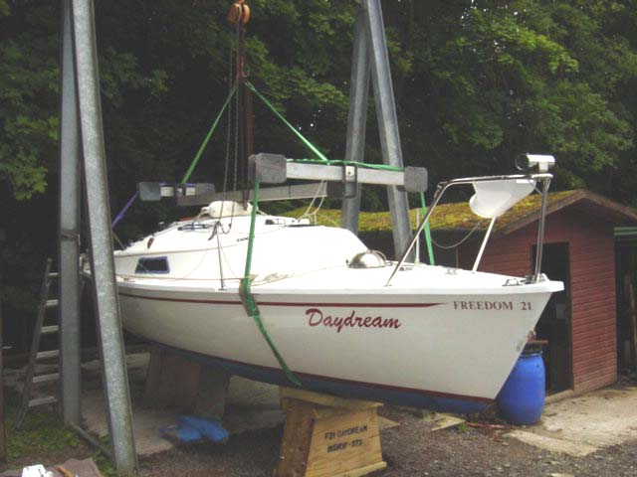I made-up two heavy duty exterior-grade ply chocks to support the boat when she was suspended in slings so that I could work under the boat with the extra security of having the boat supported by both the lifting slings and supporting chocks.

This arrangement proved to be a safe and simple way of getting access to the twin lifting keels for maintenance work and antifouling. But lifting a boat and working under it with the boat suspended in slings is a very serious matter and the utmost care must be taken to check all fittings and the condition of the lifting slings and loops before starting work. If anyone wishes to construct a similar lifting frame please contact me for a copy of my calculations of the safety factors associated with this design, dimensions of the welded fittings and a source of suitable slings and lifting strops.

Wilf Bishop

2nd January 2009