My Favourite Freedom 21 Modifications
The following are the modification that I find most useful in my Freedom 21 DAYDREAM, particularly since I spend a lot of my time sailing single-handed.
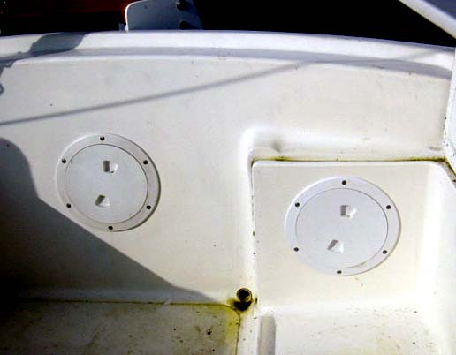
Aft Cockpit Hatches – I fitted these two hatches to allow me to replace the through-bolted rudder fittings and get access to the inside of the transom moulding to fit the boarding ladder. The hatches also allow me to get at the drain tubes that pass through the transom moulding since these can be a source of leaks and need to be resealed regularly. I feel that this is an essential modification since one cannot rely on the integrity and safety of rudder fittings on boats as old as the Freedom 21, so regular checks are essential.
Boarding Ladder – I installed a short, folding boarding ladder on the port side of the transom which has been a very useful modification, particularly since I am now in my mid-sixties and springing onboard from my tender onto the side deck is sadly no longer a real option.
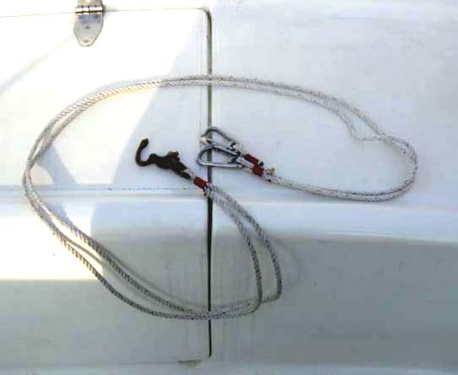
Boom Bridle – To avoid the secured boom coming adrift in strong winds I have made-up a simple boom bridle consisting of a length of line with snap-hooks at each end and a snap shackle lashed to the loop of line in the middle. The snap-hooks fit to the stainless steel eyes each side of the transom where the lifelines attach and the centre snap shackle connects to the boom end. To snug the boom down I attach the boom bridle to the boom end, fit the mainsail halyard to the boom end and haul-in the halyard until the boom bridle is tight. I then snug down the mainsheet and kicking strap to give a totally secure boom that will never dislodge and thrash about even in the worst squalls.
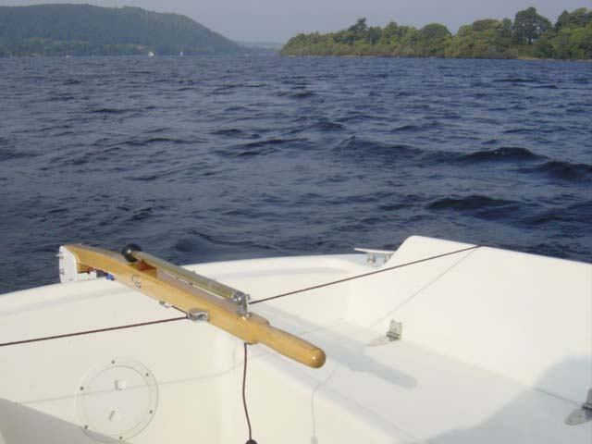
Helm Impeder – Sailing single-handed I find it essentail to be able to “lock” the tiller so that I can attend to the outboard engine or adjust the sails and this simple helm impeder is a really useful fitting that allows me to pick up my mooring by motoring up to the mooring buoy, locking the tiller, shifting the outboard into neutral and quickly going forward with the boathook to pick up the mooring strop. Without the helm impeder the whole thing could be a lot more dramatic. Also in wind strengths up to around 20 mph I can set the boat on a close-hauled course and simply “lock” the tiller so that I can go below or go forward in complete safety with the boat holding her close-hauled course, even following the wind shifts whilst maintaining the same course in relation to the apparent wind. However I don’t know if this is a characteristic of all Freedom 21 keel arrangements – I only know that it works amazingly well for the UK twin lifting keel version. The detailed description of this system is given in one of my other articles on our website.
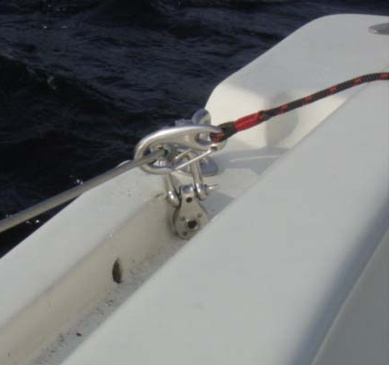
Aft Side Deck Drain Holes – One feature of the Freedom 21 design is that rainwater collects in puddles over the aft 18 inches or so of the narrow side-deck moulding. I fixed this problem by drilling a 10mm dia drainage hole through the “lip” of the side-deck moulding by drilling up from underneath the the gunwale. I took careful measurements and drew-out the full-scale shape of the gunwale region. I then made a scrap plywood template to guide the drill angle. One slight problem is that the drilled hole opens up a gap between the deck & hull moulding which needs to be filled with thickened epoxy paste. I will epoxy a piece of thin-walled stainless steel tube into each of these holes to ensure that no water can drain into the hull.

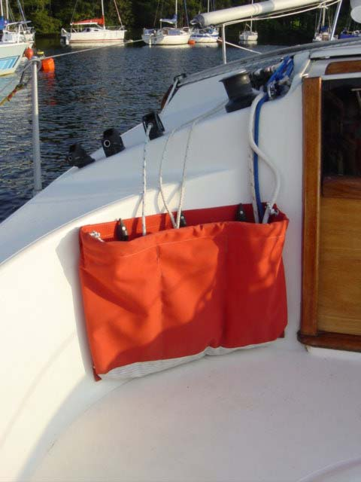
Halyard Bags – To me the joy of sailing a Freedom 21 is the ease with which the gunmount spinnaker can be hoisted and doused and my favourite “show-off” trick is to blaze past the yachtclub in a strong breeze with spinnaker set, standing tall in the cockpit, tiller between my legs, nonchalently playing the spinnaker reins – hey, it really makes up for the poor upwind perfromance believe me. However, after dousing the spinnaker the “stringfest” in the cockpit is just incredible and the only answer is to fit a large three-pocket halyard bag each side of the forward cockpit bulkhead. These halyard bags must have a mesh base to allow water to drain out and need to be made from stiff fabric to allow them retain their “open mouth” configuration. Here in the UK excellent three-pocket bags are available “off the shelf” from C&J Marine Textiles at www.cjmarine.co.uk
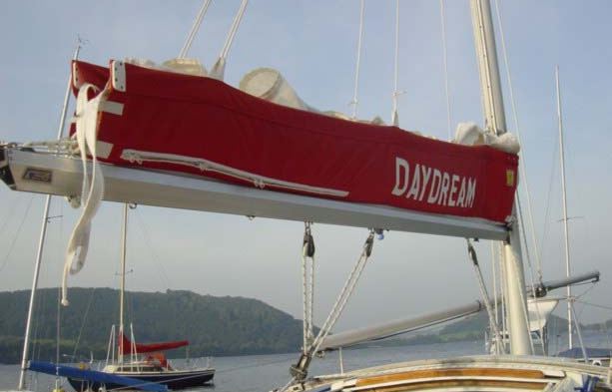
Stacking Sail Cover – My boat came with a brand new zip-up stacking sail cover that incorporates a three-line lazy jack system which is a great aid to the single-handed sailor. I can start-up my outboard, head-up into the wind and drop the sail which comes down between the lazy jacks into the sailcover in seconds and that is it – I have nothing else to do until I am on the mooring and coffee is brewing when I just zip-up the cover over the neatly stowed sail – wonderful. Again the sail cover is from C&J Marine Textiles (PACK-A-MAIN).
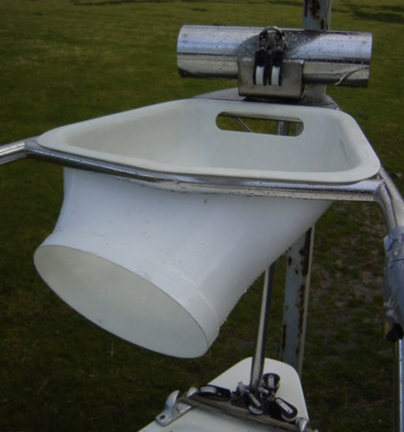
Spinnaker Chute Mouth – I designed and made-up a fibreglass spinnaker chute mouth for my Freedom 21 since the shaped canvas “sock” that came with the boat was really unsuitable and was the cause of frequent jambing of the half-doused spinnaker. My design works with a simple straight taper canvas “sock” that is secured to the spinnaker mouth with shockcord and I find that hoisting and dousing of the spinnaker is a dream. Unfortunately it seems that the dimensions of the UK Freedom 21 pulpit aparture differ from those of the USA-built boats so it seems that my moulding will not fit USA-built Frredom 21’s. The details of how I made this component is given in my artice on our website.
Wilf Bishop
6th October 2008

