Freedom 21 Spinnaker Chute Mouth
I have been frustrated by the problem of rigging the canvas spinnaker launch tube on my Freedom 21 which involves lashing the canvas tube to the pulpit framework with elastic bungee cords which results in a poor fit since my canvas tube has been badly cut and does not seem to correspond to the shape of the aperture formed by the pulpit tube assembly. I decided that what I needed was a moulded fibreglass chute mouth that could be permanently fitted to the pulpit assembly so that I could simply slide the spinnaker launch tube over the aft-facing end of the chute mouth and lash it with elastic bungee cord to keep it in place. I also wanted a moulding that was “skewed” to port to line up with the position of the spinnaker launch tube which I carry on the port side of my boat.
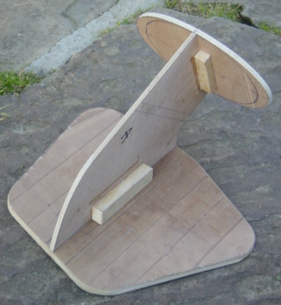
I made-up the three pattern elements in 8mm (5/16”) plywood which I screwed & glued together as shown in the photo. I then filled-in around the central “spine” of the pattern with slabs of 25.4mm (1”) polystyrene foam glued with epoxy resin. I then sanded the foam to shape with 60 grade abrasive paper and covered the finished pattern with one layer of 140 gsm (16 oz/sq.yd) plain weave glass fabric & epoxy resin. The final part shape was simply a freehand blending to the pattern shapes to give a smooth transition. The fibreglass covered foam pattern needed further filling & fairing and this was done with polyester car body filler and more sanding. The pattern was then screwed to a medium density fibreboard (MDF) base board and the joint where the pattern meets the base board was faired with polyester car body filler to a 25.4mm (1”) radius.
The raised area at the rim of the elliptical section was formed by attaching a strip of 25.4mm (1”) wide 3mm (1/8”) thick cork strip with double-side adhesive tape and fairing the joint step with polyester car body filler. I checked the effectiveness of this kind of flange for retaining the spinnaker tube with elastic bungee cord by making-up this flange geometry on a scrap piece of large diameter plastic pipe and checking how well the spinnaker tube was retained by the elastic bungee cord – it worked fine.

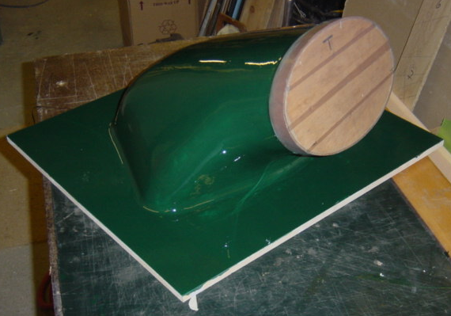
The finished pattern was painted with two-part polyurethane paint and finished with polishing compound. To make a “female” mould tool from this “male” pattern it was necessary to create a split-line for the pattern and this was achieved by making a plywood split-line former and fixing this to the pattern. The mould tool halves were made-up with 2 layers of clear gel coat and 8 layers of 450 gsm (52 oz/sq.yd) chopped strand mat fibreglass. After manufacture of the split mould I laminated some plywood stiffeners into the mould tool halves along the “crest” of the split-line to stiffen this area if I ever needed to exert strong leverage to open the split mould after manufacture of a part.

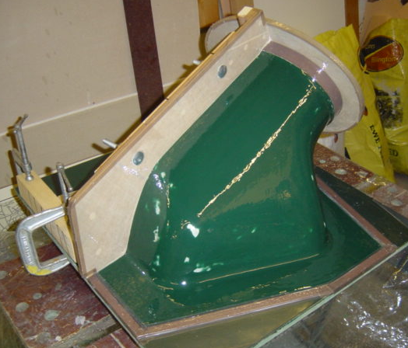
This is the pattern ready for manufacture of the first tool half with clear gelcoat applied ready for glass/polyester resin layup. The plywood end plate and splitter plate have been coated with a Teflon adhesive tape to assisit in tool release. I have used dome-end bolts in the splitter plate to form concave hollows in the first tool half flange, so that when the second tool half is moulded from the first tool half a positive male & female location feature is formed to accurately align the two tool halves on assembly.

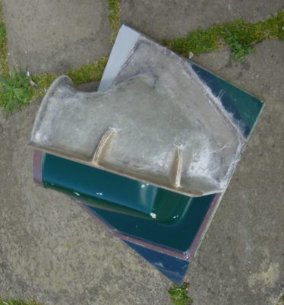
Top view of the first mould tool half after the splitter plate has been removed. Note the plywood stiffening on the spine of the mould tool that reinforce the moulding in this area to prevent distortion and damage when parts need to be removed from the final two-part mould tool.
The second mould tool half was then laminated on the pattern and after full cure the two mould tool halves were removed from the pattern and cleaned-up.

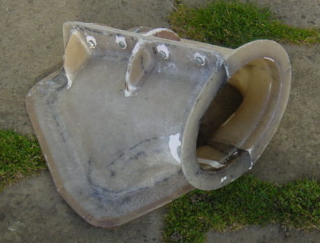
The finished two-part mould tool showing the line of bolts joining the split tool halves. The dark lines in the clear polyester resin show where I used a black felt tip pen to mark out the shape of the individual fibreglass elements in the layup. The presence of this ink line seems to have no effect on the structural integrity of the glass fibre moulding?

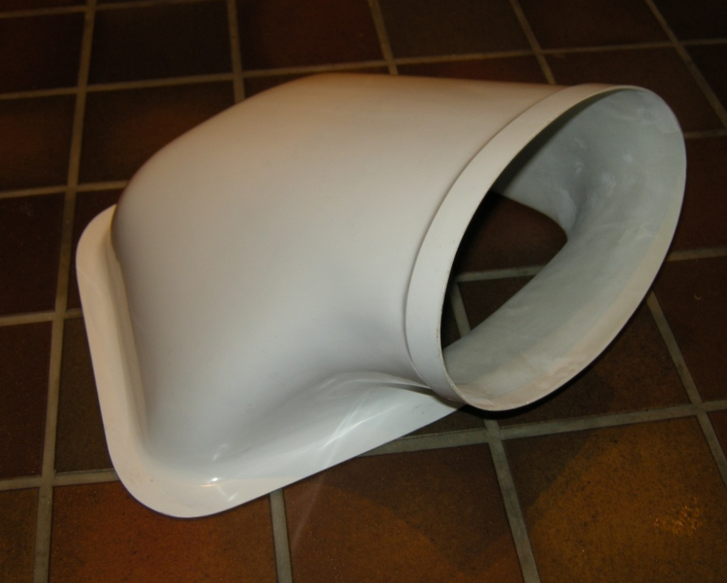
The finished spinnaker chute showed no sign of the mould tool split line after careful wet & dry sanding and polishing.

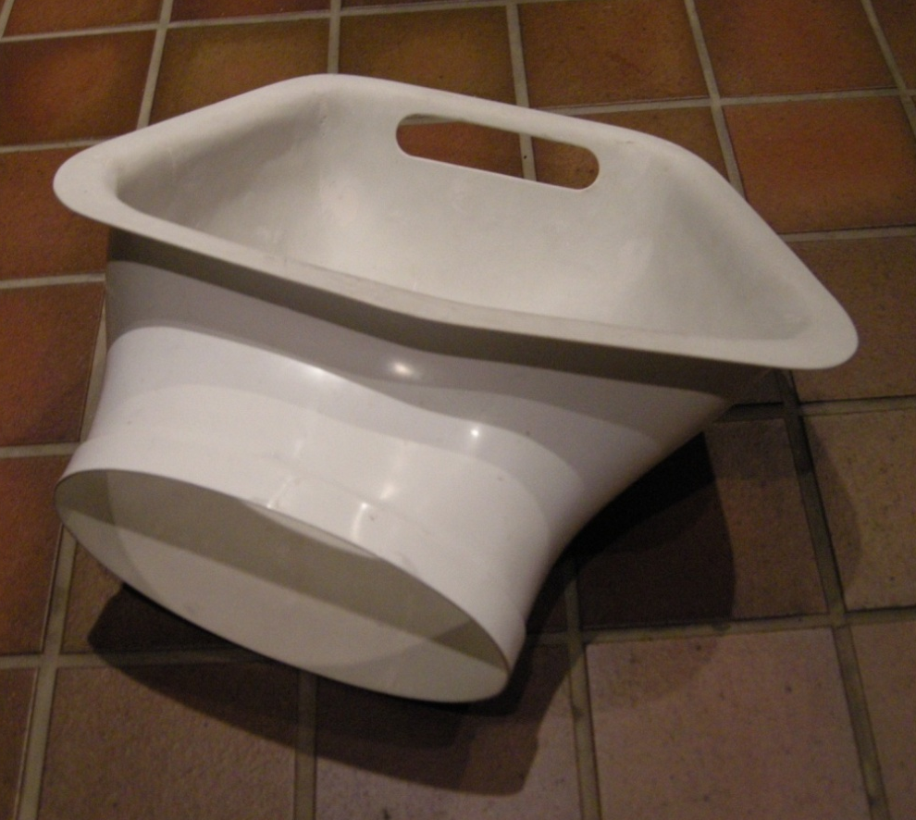
The slot in the front of the spinnaker chute allows the control lines for the spinnaker boom to pass through the front face of the moulding.
The port “skew” on the alignment of the spinnaker chute is clearly seen in this photo.

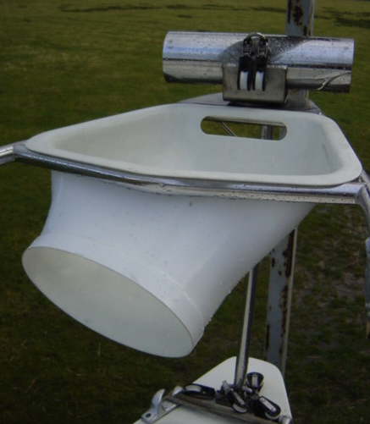

Finally - the finished spinnaker chute in position on the bow pulpit. I plan to hold the chute in position with disposable plastic wire harness straps by drilling small holes in four positions around the perimeter of the moulding and strapping the chute down to the bow pulpit stainless steel tubing.
Yes it was a long, drawn-out way to get the spinnaker chute that I wanted and as my wife reminds me there were many jobs around the house that I could (should?) have been busy with. However I thoroughly enjoyed the job and look forward to many seasons of easier spinnaker handling.
Wilf Bishop
13th March 2008

