Freedom 21 “Hands free” Sailing

Browsing the Internet I discovered a simple and low-cost method for stiffening the movement of the Freedom 21 tiller to enable me to go forward for hoisting the spinnaker and making minor adjustments to the sail set-up. The device in question is called a Helm Impeder and was developed by John Huntingford who published the information on the UK Dinghy Cruising Association website www.dca.uk.com/articles/himpeder.htm This note simply shows how the device can be fitted to the Freedom 21. The device is simplicity itself and is made up from the odds & ends that most of us have in our spares locker. The sketch below shows the system in outline.
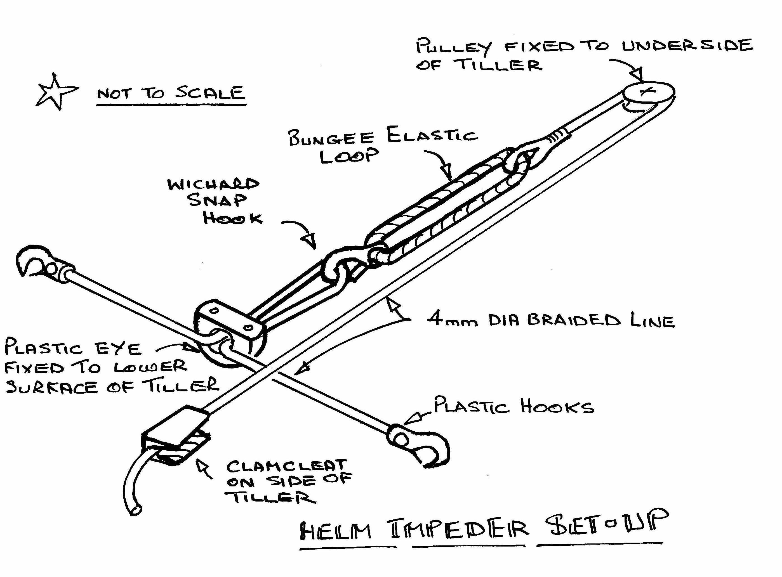
I find that the ideal position for clipping the sheet horse plastic hooks are the aft guardrail wire eyes where they fix to the deck eyes. The plastic hooks enable one to quickly “unhook” the complete system when it is not needed and the Wichard snap hook allows the whole set-up to be completely removed from the tiller with one hand. To make removal easier I also use an “open” Clamcleat on the side of the tiller. The overall set-up as installed on DAYDREAM is shown in the photo below.

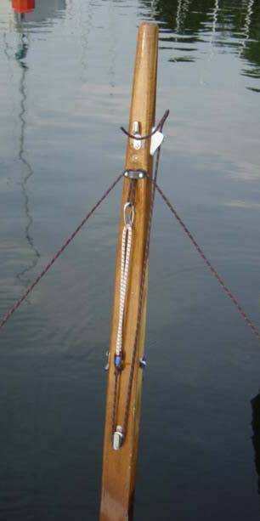
I find that this set-up works wonderfully well with my boat. However my comments about the excellent self-steering characteristics of the system may well only apply to the twin drop keel UK version of the Freedom 21 since this particular keel arrangement does have very good tracking characteristics?

Close hauled sailing to windward on mainsail alone I find that in moderate winds I can set a course and set the system tension to hold the tiller and the boat sails “hands free”. In fact the boat luffs-up in the gusts and follows wind shifts – amazing. I have found that in strong winds this self-steering does not seem to work so well and I guess that this self-steering behaviour may well only apply to a narrow “window” of wind strengths?

Off the wind and particularly running downwind one only has a short time to leave the cleated helm and attend to other matters before the boat starts to track away from the desired course. However I find that there is enough time to go forward & hoist the spinnaker before things get out of hand.

I am moored in a crowded mooring with very little room for error when picking up the mooring and I find that sailing single-handed I can line-up the boat and fix the helm when approaching the mooring, push the outboard into neutral and go forward to pick up the mooring with the utmost ease. A very useful device – thanks again to John Huntingford and the DCA.
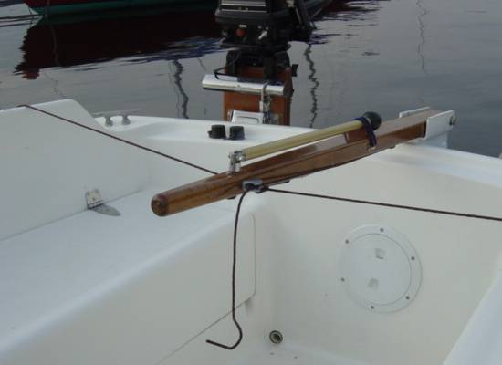

General arrangement of the system on DAYDREAM

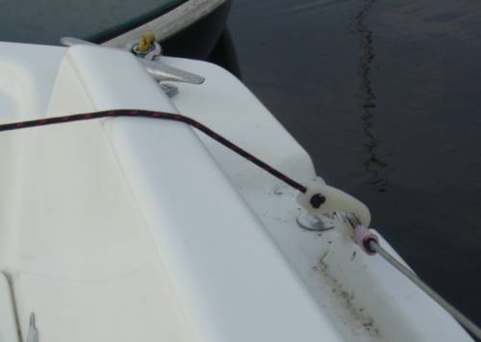

Transverse sheet horse clipped to the aft guardrail eye on each side

